Science 10 Name:
Number #
Ecological Succession
Slide 1 – Natural Changes in Ecosystems

- Natural selection - species change (adapt) to their environment
- Adaptive radiation - new species arise.
- Ecological succession – changes the types of organisms that live in an ecosystem.
Slide 2 – Ecological Succession

Changes in the types and amount of species in an ecosystem over time.
Changes in biodiversity in an ecosystem over time.

Slide 3 – Primary Succession

- Change in community composition on a site which previously has had no living organisms.

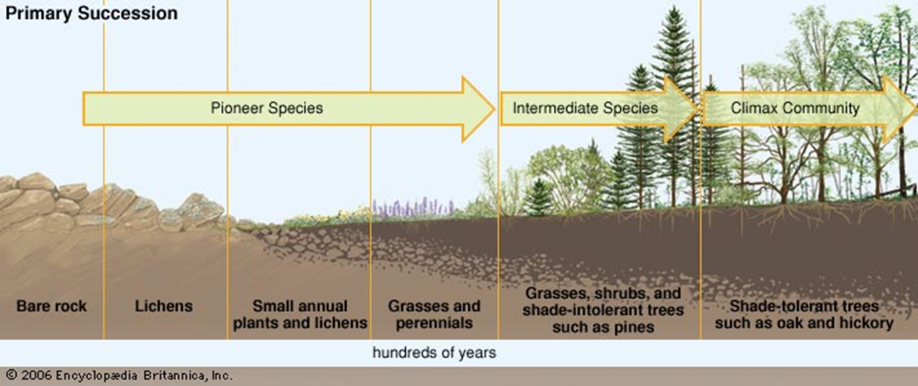

Slide 4

Example: Colonization following a large scale disturbance

Slide 6 – Lichen

Lichens are an example of Mutualism
- 2 organisms, both benefit
- Fungus and algae
- Lichens secrete (release) chemicals that break down rock.
- This type of weathering (plus wind, rain and freezing) helps produce soil.
Pioneer species:

Pioneer species: change environment by producing soil and providing food for other organisms.

Slide 7 - Pioneer Species

- First plants to colonize an area: mosses, lichens & herbs
- Rapid colonizers
- Rapid growth (opportunistic)
- Relatively poor competitors in established environments
- Due to symbiotic relationship (algae use photosynthesis), they can survive in low nutrient environments.

Slide 10

Climax communities = a mature community
Tropical rainforests, grasslands and deserts are all examples of climax communities.
Appear to be unchanged but this is a mistaken assumption.

Slide 11 – Climax Community???

- Difficult to identify
- May take 100’s or 1000’s of years to reach this stage
- Stage at which system has reached steady state equilibrium
- Most permanent of all the stages
- Determined by climatic or soil factors unless humans interfere (e.g. poor soil quality, grazing, preventing forest fires, selective logging)

Slide 12 – Secondary Succession

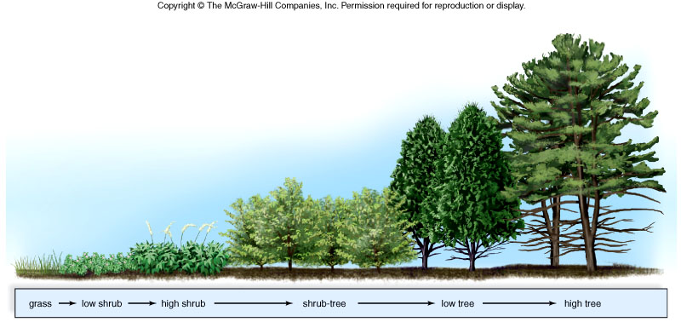
Slide 13 – An example of Secondary Succession

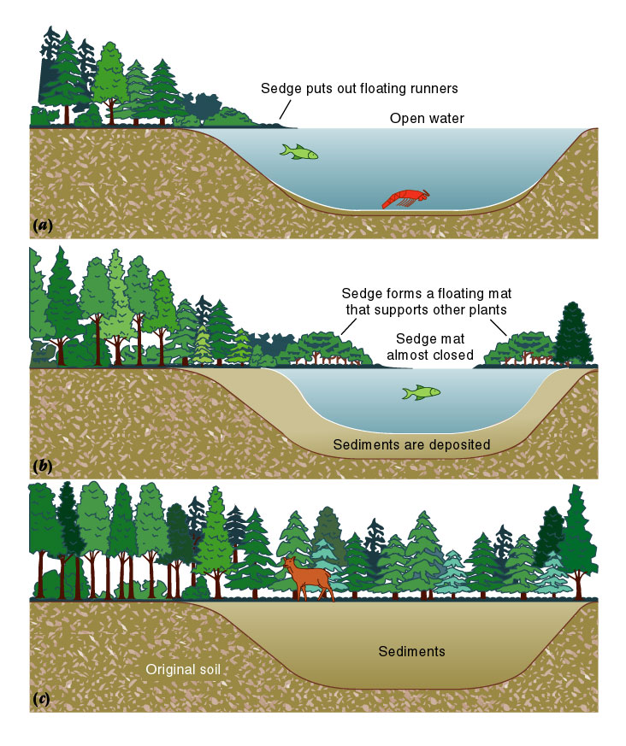
Slide 19 – How Natural Events Affect Ecosystems

- Include events such as storms, fires, flooding, Tsunamis, droughts, overgrazing, and human activities
  - They damage biological communities
  - They remove organisms from communities

Slide 20 – Succession due to Natural Events


