Science 10 Year End Chemistry Review Name:

Atomic Theory and Bonding
I. Summary of Key Points
• Atoms are composed of protons and neutrons, which make up the nucleus, and electrons, which surround the nucleus in patterns.
• Bohr diagrams show the arrangement of protons, neutrons, and electrons in atoms and also in ions.
• Ions are formed from atoms that have lost or gained electrons.
• Compounds can be ionic or covalent.
• Lewis diagrams show the arrangement of bonds within compounds.

II. Study Notes
Atomic Theory
1. An atom is the smallest particle of an element that has the properties of that element.
It includes the following smaller subatomic particles:
• Protons are subatomic particles that have a 1+ (positive) charge.
• Neutrons are subatomic particles that do not have an electric charge.
• Electrons are subatomic particles that have a 1− (negative) electric charge
2. An element is a pure substance that cannot be chemically broken down into simpler substances.
Example: Oxygen (O) is an element.
3. A compound is a pure substance that is made up of two or more different elements that have been combined in a specific way.
Example: H2O is a compound made of the elements hydrogen and oxygen.
.

The Nucleus
1. The nucleus is at the centre of an atom (Figure 4.1).
• The nucleus is composed of protons and neutrons.
• Electrons exist in the area surrounding the nucleus.
2. The number of protons = the number of electrons in every atom
3. The atomic number = the number of protons = the number of electrons
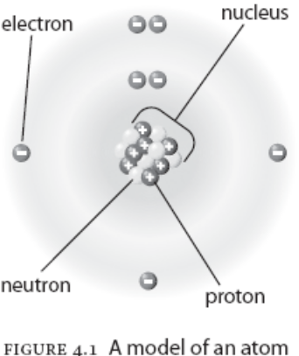

Quick Check
1. Where is each particle located in an atom AND what is its charge?
a) proton __________________________________________
b) neutron _________________________________________
c) electron _________________________________________

2. What does “atomic number” mean?
________________________________________________________________________

The Periodic Table and Ion Formation
1. Atoms gain and lose electrons to form bonds.
• When atoms gain or lose electrons, they become electrically charged particles
called ions.
2. Metals lose electrons and become positive ions.
• Some metals are multivalent, which means they lose electrons in different ways (Figure 4.2).
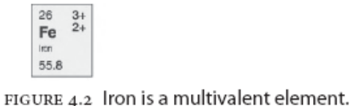
– Iron (Fe) loses either two electrons (Fe²⁺) or three electrons (Fe³⁺) as shown in the periodic table.

3. Non-metals gain electrons and become negative ions.

Quick Check
1. How do metals become positive ions?
______________________________________________________________________________

2. How do non-metals become negative ions?
______________________________________________________________________________

Bohr Diagrams
1. A Bohr diagram is a model of the atom that describes the arrangement of an element’s subatomic particles: neutrons and protons in the nucleus and electrons in electron shells
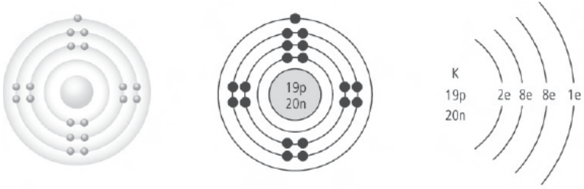
• Electron shells are regular patterns or energy levels around the nucleus.
• There is a maximum of 2 electrons in the first shell, 8 electrons in the second shell, and 8 electrons in the third shell.
• Electrons in the outermost shell are called valence electrons.
2. Patterns of electron arrangements in groups:
• Except for the transition elements (Groups 3–12), the last digit of the group number equals the number of valence electrons.
Examples: Group 1 = 1 valence electron, Group 13 = 3 valence electrons

3. By losing or gaining electrons, atoms can have the same number of valence electrons as the nearest noble gas.
• The noble gas elements (group 18) have full electron shells and are very stable.
4. Electrons can exist singly as unpaired electrons, or they can be in pairs, called paired electrons.

Lewis Diagrams
1. Lewis diagrams represent the atom of an element by showing only the outer valence electrons.
• Dots representing electrons are placed singly around the element symbols the fifth electron is reached, then they are paired



Lewis sodium atom Lewis chlorine atom

Quick Check
1. Draw a Bohr diagram of the following atoms:
a) Li b) S

2. Draw a Lewis diagram of the following atoms:
a) K c) F

Forming Compounds
1. In ionic bonding, the bond forms as a result of the attraction between positively charged ions and negatively charged ions.
• Metals lose valence electrons and non-metals gain electrons when forming ions
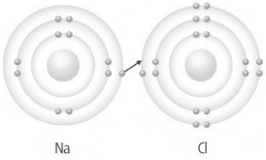
3. In a Bohr diagram of an ionic compound, large square brackets are placed around the diagram with the ion charge shown just outside the end bracket
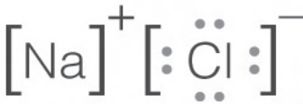
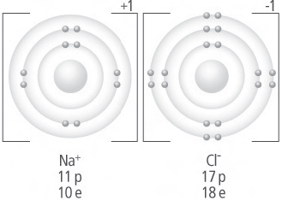

4. Lewis diagram of sodium chloride:
Covalent Bonding
1. In covalent bonding, the bond forms through the sharing of one or more pairs of electrons.
• Covalent bonds form when electrons are shared between two non-metals.
• The shared pair of electrons involved in a covalent bond is called the bonding pair.
• A pair of electrons in the valence shell that is not used in bonding is called a lone pair.
• Electrons are NOT transferred in covalent bonding

Example: Hydrogen and fluorine share valence electrons to form hydrogen fluoride
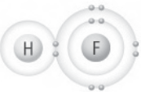

2. A molecule is a group of atoms in which the atoms are bound together by sharing one or more pairs of electrons.
3. In diatomic elements, pairs of electrons are joined by covalent bonds because the two-atom molecules are more stable than the individual atoms.
• Diatomic elements include hydrogen (H2), nitrogen (N2), oxygen (O2), fluorine (F2), chlorine (Cl2), bromine (Br2), and iodine (I2). REMBER? 7 + 1 diatomic elements

3. Lewis diagrams of covalent bonding:
• The bonding pair of electrons are usually drawn as a straight line
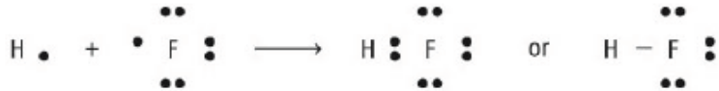

Quick Check
1. What combination of elements forms an ionic compound? ________________ + ________________

b) Are electrons shared or transferred in this type of compound? _______________

2. What combination of elements forms a covalent compound? ________________ + ________________

b) Are electrons shared or transferred in this type of compound? _______________

3. Draw a Lewis Diagram of the following compounds. Label lone pairs and bonding pairs.
a) NH₃ b) H₂O

Sample Questions
For each sample question in this review, cover up the column “Why it is right/why it is wrong” with a piece of paper. Then read the question, circle your choice, then uncover the explanation.
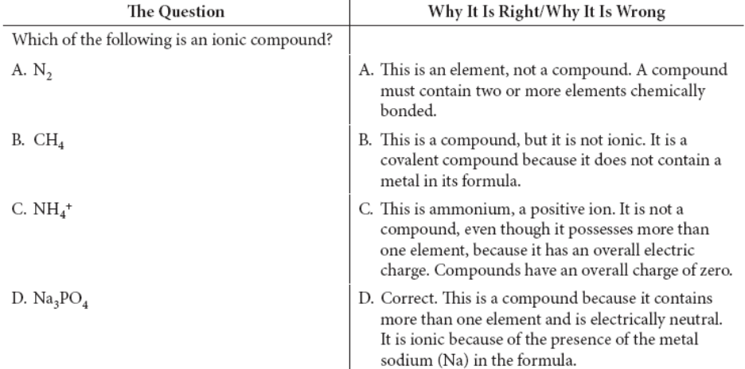

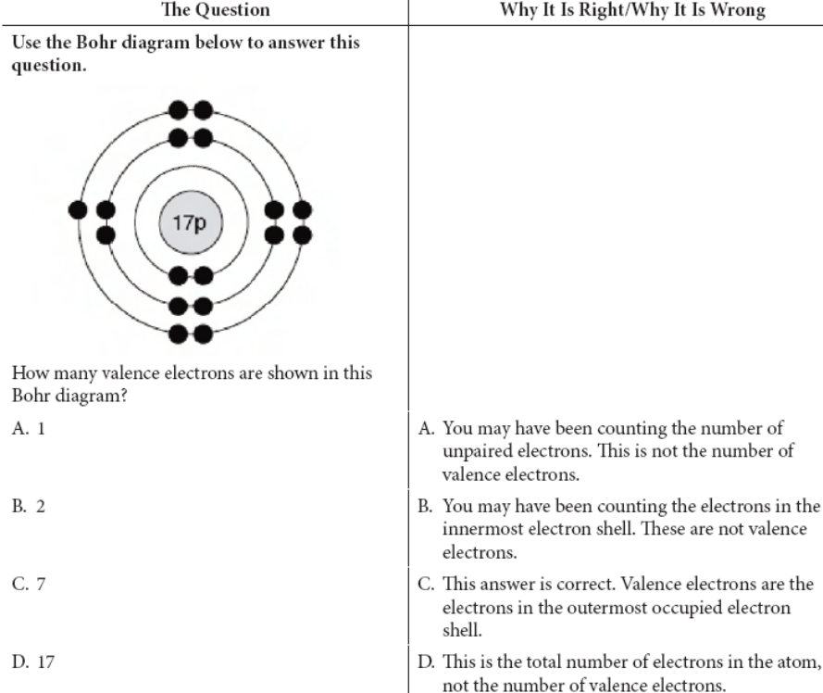

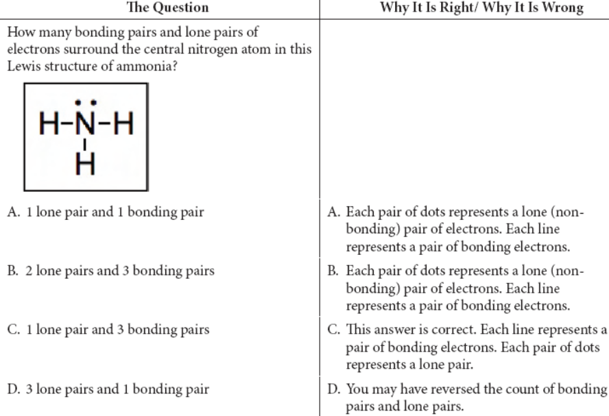

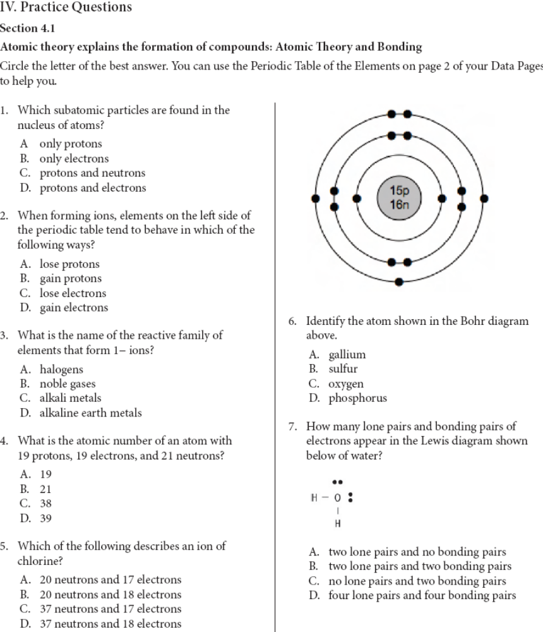
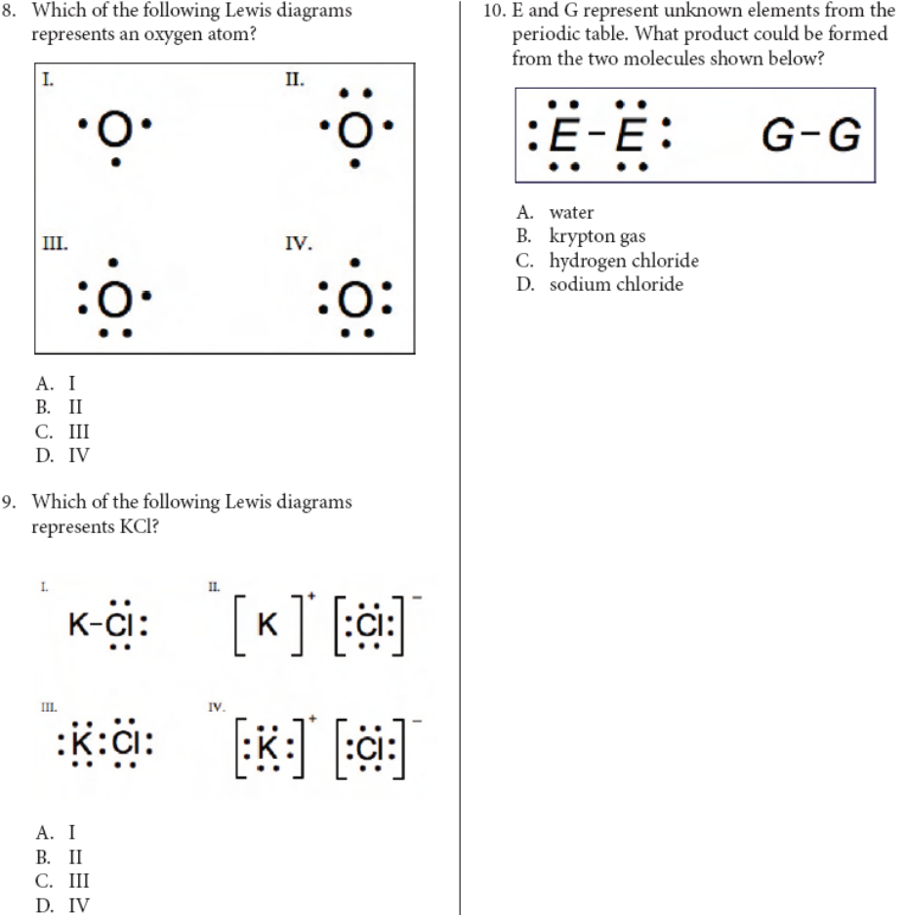

Names and Formulas of Compounds
I. Summary of Key Points
• Compounds can be represented with both a name and a chemical formula.
• In an ionic compound, the first part of the name indicates the positive ion and the second part indicates the negative ion.
• In the formula of an ionic compound, the subscripts indicate the ratio in which the positive ions and negative ions are present together in the compound.

II. Study Notes
The Chemical Name of an Ionic Compound
1. The name of an ionic compound always has two parts, one for each type of ion in it.
• The name of an ionic compound = positive ion + negative ion + -ide
Example: magnesium (positive ion) + oxygen (negative ion) + -ide
Answer: magnesium oxide
2. Ionic formulas are based on the ions of the atoms involved.
Example: What is the name of Ca3N2?
Ca, the positive ion, is calcium
N the negative ion, is nitrogen
Drop the end of the negative ion and add -ide
Answer: calcium nitride

The Chemical Formula of an Ionic Compound
1. In an ionic compound, the positive charges balance out the negatives.
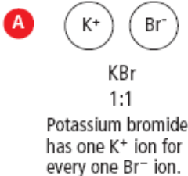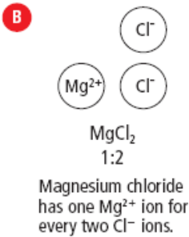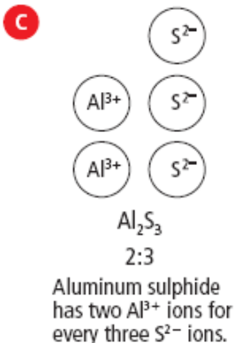

Quick Check
1. Name the following compounds:
a) (a) Li3P ____________________________________________________________________
(b) CaCl2 ______________________________________________________________________
(c) ZnO _______________________________________________________________________

2. Write the formulas of the following ionic compounds.
(a) sodium sulfide _______________________________________________________________
(b) magnesium iodide ____________________________________________________________
(c) aluminum oxide ______________________________________________________________

Names and Formulas of Compounds Containing a Multivalent Metal
1. Some metals are multivalent, which means they have more than one ion form.
2. On the periodic table, the most common form of the ion is listed at the top of the element’s box.
3. In the name of the compound, Roman numerals are used following the positive ion to indicate which ion was used
Example: What is the formula for manganese (III) sulfide?
Manganese (III) is Mn³⁺
Sulfur is S^{2–}
Answer: Mn2S3
Quick Check
1. Write the formulas of the following ionic compounds.
(a) copper (I) oxide ______________________________________________________________
(b) lead (IV) iodide ______________________________________________________________
(c) lead (II) chloride _____________________________________________________________

2. Name the following ionic compounds containing a multivalent metal ion. Use a Roman numeral in the metal ion’s name.
(a) Cr₃P₂ ______________________________________________________________________
(b) MnCl₂ _____________________________________________________________________
(c) Co₂O₃ _____________________________________________________________________
(d) FeN _______________________________________________________________________

Polyatomic Ions
Refer to Names, Formulae, and Charges of Some Polyatomic Ions, on page 4 of your Data Pages.
1. Polyatomic ions are ions composed of more than one type of atom
• The whole group has a + or – charge, not individual atoms.
Example 1: What is the formula of sodium sulfate?
Na⁺ and SO4²⁻
Na2SO4
Example 2: What is the name of the compound KClO?
K⁺ = potassium
ClO⁻ = hypochorite
potassium hypochlorite

Quick Check
Refer to Names, Formulae, and Charges of Some Polyatomic Ions, on page 4 of your Data Pages.
1. Write the formulas of the following ionic compounds containing polyatomic ions.
(a) cesium sulphate ______________________________________________________________
(b) titanium(IV) hydrogen carbonate ________________________________________________
(c) ammonium dichromate ________________________________________________________

2. Name the following ionic compounds containing polyatomic ions. The metal ion may need to be written using a Roman numeral.
(a) NaClO₄ ____________________________________________________________________
(b) Mg₃(PO₄)₂ _________________________________________________________________
(c) CuSO₄ _____________________________________________________________________

3. Give the number of each type of atom indicated by the formula, as well as the total number of
atoms. (e.g., MgF₂ has one Mg and two F for a total of three atoms)
(a) K₃PO₄ _____________________________________________________________________
(b) (NH₄)₂SO₄ _________________________________________________________________
(c) nickel(III) carbonate __________________________________________________________

Names and Formulas of Covalent Compounds and Naming Binary Covalent Compounds
1. Covalent compounds are made up of two or more non-metals, sharing electrons.
2. Covalent molecules have subscripts that show the actual number of atoms in the molecule.
3. The names of binary covalent compounds (two non-metal atoms) use a system of prefixes.
• Prefixes are often used before the atom name to indicate the number of atoms in the molecule.
(See page 4 of your Data Pages for a list of prefixes.)
Examples: CO = carbon monoxide, CO₂ = carbon dioxide

Quick Check
1. Write the formula of each covalent compound.
(a) sulfur trioxide________________________________________________________________
(b) dinitrogen monoxide __________________________________________________________
(c) phosphorus pentachloride _____________________________________________________

2. Write the name of each covalent compound
(a) PBr₃_______________________________________________________________________
(b) N₂S₃ _______________________________________________________________________
(c) N₂O₄ _______________________________________________________________________

Comparing Ionic Compounds and Covalent Compounds
To determine whether a compound is ionic or covalent examine the formula.
• Ionic compounds start with a metal or the ammonium ion (NH₄⁺).
• Covalent compounds start with a non-metal.

Quick Check
1. Identify each of the following compounds as either ionic or covalent, and name them.
(a) (NH₄)₃P ________________________________ ___________________________________
(b) OBr₂ __________________________________ ___________________________________
(c) FeF₃ __________________________________ ___________________________________

2. The compounds below have similar-looking formulas but may have very different names. Classify each compound as ionic or covalent, and then name each compound.
(a) PbO₂ __________________________________ ___________________________________
(b) SO₂ ___________________________________ ___________________________________
(c) SnO₂ __________________________________ ___________________________________

Sample Questions
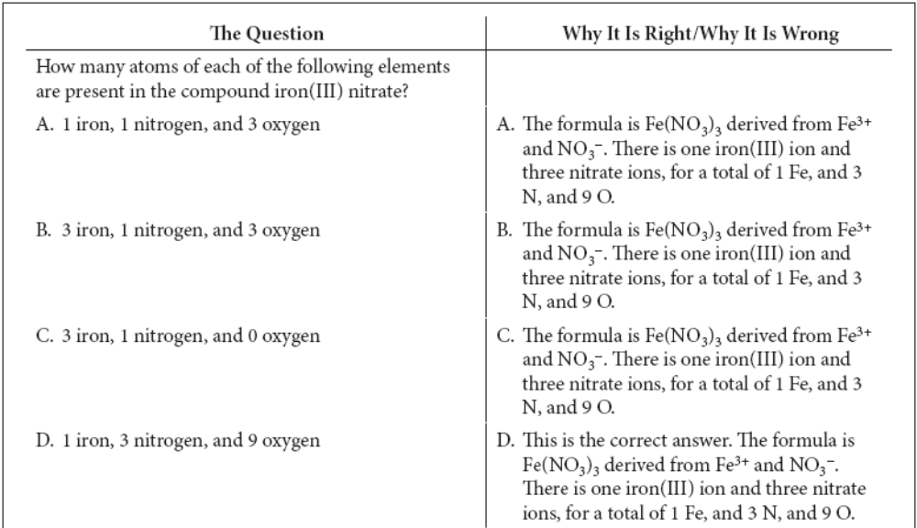
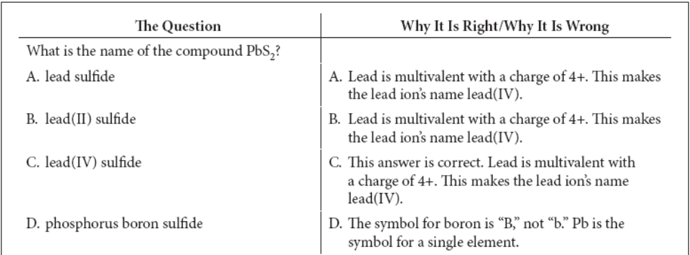
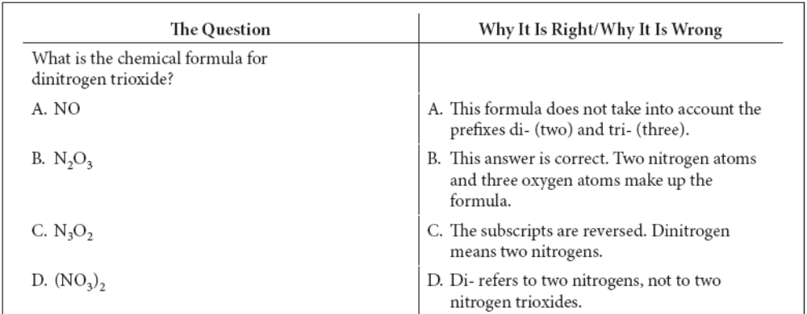

Practice Questions. Circle the best Answer.
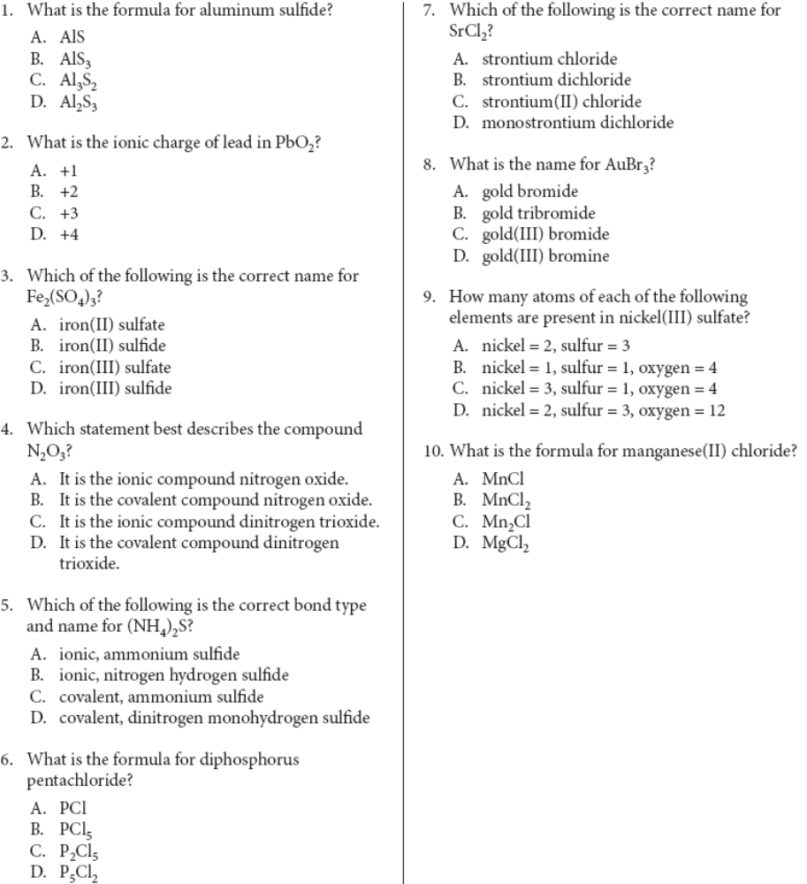
Chemical Equations
I. Summary of Key Points
• A chemical change is a change in the arrangements and connections between ions and atoms.
• Chemical reactions can be represented using a chemical equation, written in words or symbols.
• In a chemical reaction, the reactants are written to the left of an arrow and the products are written to the right.
• The symbols for states of matter may be used to show whether each reactant or product is solid, liquid, gas, or aqueous.
• Chemical reactions obey the law of conservation of mass, and atoms are neither created nor produced in a chemical reaction.
• Chemical equations are balanced using the lowest whole number coefficients, which are numbers written in front of the pure substances in the reaction.

• Chemical reactions can be written in different ways.
• A word equation:
Example: Nitrogen monoxide + oxygen → nitrogen dioxide
• A symbolic equation is a set of chemical symbols and formulas that identify the reactants and products in a chemical reaction.
Example: 2NO + O₂ → 2NO₂

Conservation of Mass in Chemical Change
Chemical change means new compounds are created, but no new matter is created or destroyed; atoms are just rearranged.
• All of the matter in the reactants = all of the matter in the products

Writing and Balancing Chemical Equations
1. The simplest form of chemical equation is a word equation.
Example: Potassium + oxygen → potassium oxide
2. A skeleton equation shows the formulas of the elements/compounds but not quantities of atoms.
Example: K + O₂ → K₂O
3. A balanced chemical equation shows all atoms and their quantities.
Example: 4K + O₂ → 2K₂O

Quick Check
1. List the total number of each type of atom in the following reactants.
(a) 3Cl₂ + 2CrI₃ _______________________________________________________________
(b) Pb(NO₃)₄ + 4NaI ____________________________________________________________

Hints for Writing Word Equations
1. The chemical symbol is used for most elements that are not in a compound, except for diatomic elements: H₂, N₂, O₂, F₂, Cl₂, Br₂, and I₂.
2.Several common covalent molecules containing hydrogen have common names that do not help in writing chemical formulas.
• Methane is CH₄, water is H₂O, glucose is C₆H₁₂O₆, ethane is C₂H₆, and ammonia is NH₃.

Strategies for Balancing Equations
1. Balance chemical equations by following these steps.
• Trial and error will often work for simple equations.
• Balance compounds first and elements last.
• Only add coefficients; NEVER change subscripts.
• If H and O appear in more than one place, attempt to balance them LAST.
• Polyatomic ions (such as SO₄ ^{2–}) can often be balanced as a whole group.
• Always double-check after you think you are finished.

Quick Check
1. Balance the following skeleton equations.
(a) ____ Al + ____ Cl₂ → ____ AlCl₃
(b) ____ CH₄ + ____ O₂ → ____ CO₂ + ____ H₂O
(c) ____ Ca(NO₃)₂ + ____ Cu₂SO₄ → ____ CaSO₄ + ____ CuNO₃
(d) ____ Na₂CO₃ + ____ Ni(NO₃)₃ → ____ NaNO₃ + ____ Ni₂(CO₃)₃
2. Write skeleton equations for the following chemical reactions and then balance them.
Be sure to check your formulas carefully before you begin to balance.
(a) calcium fluoride + potassium → potassium fluoride + calcium
____________________________________________________________________________
(b) aluminum hydroxide + hydrogen bromide → aluminum bromide + water
____________________________________________________________________________
(c) chromium(III) iodide + potassium carbonate → chromium(III) carbonate + potassium iodide
____________________________________________________________________________
(d) hydrogen nitrate + barium carbonate → barium nitrate + water + carbon dioxide
____________________________________________________________________________

Sample Questions Explained
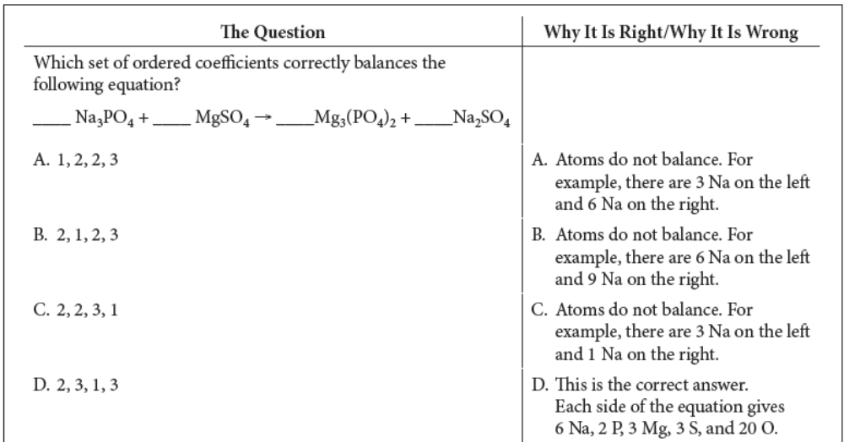
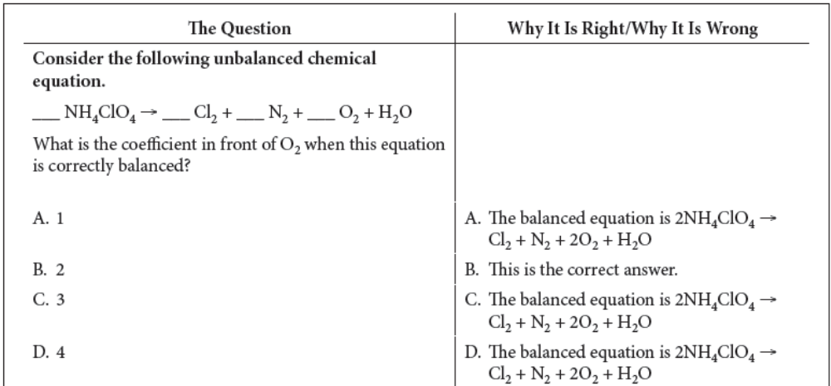

Practice Questions. Circle the best answer.

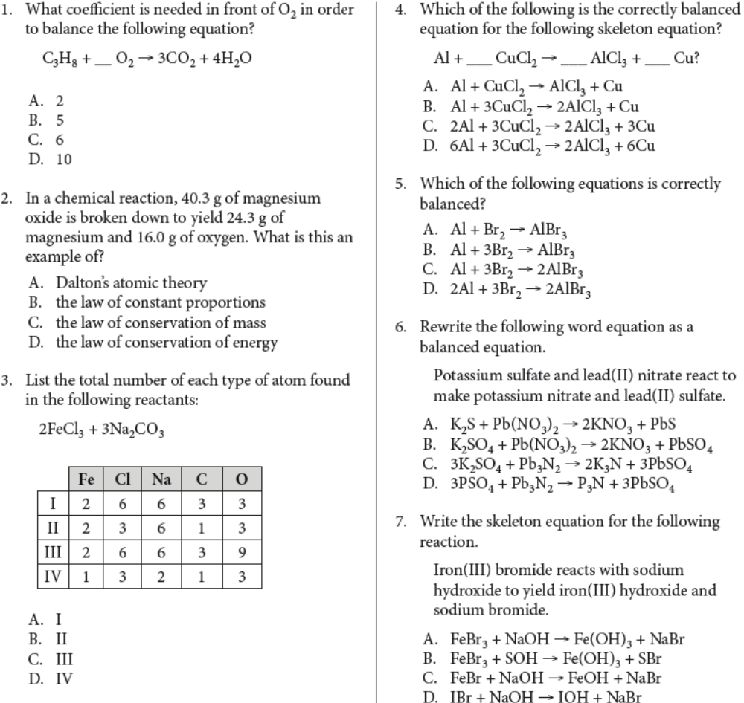
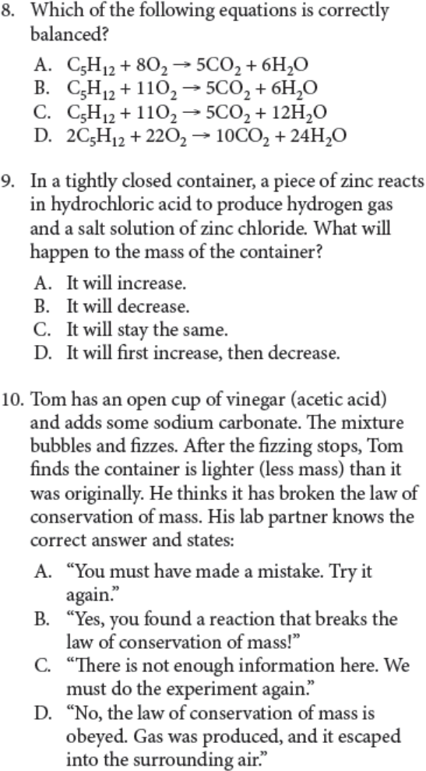

5.1 Acids and Bases
I. Summary of Key Points
• Many common pure substances can be classified according to whether they are acids or bases.
• Acid-base indicators are chemicals that change colour in response to acidic or basic conditions.
• The pH scale is a number scale for measuring how acidic or basic a solution is.
• pH<7 is acidic, ph=7 is neutral, and a pH > 7 is basic.
• Generally, the chemical formula for an acid starts with H (hydrogen) on the left of the formula.
• Bases generally have an OH on the right of the chemical formula.

II. Study Notes
The pH Scale
1. Each decrease of 1 on the pH scale indicates 10× more acidic.
Examples: pH=4 is 10 times more acidic than pH=5.
pH=3 is 1000× more acidic than pH=6.
2. If a solution has a pH = 7, it is said to be neutral, neither acidic nor basic. Pure water is neutral

Quick Check
1. What is the pH range for each of these solutions?
(a) acidic ______________________________
(b) basic ________________________________
2. How many times has the acidity level increased if the pH drops from pH=4 to pH=3? ___________
3. How many times has the acidity level increased if the pH drops from pH=6 to pH=2? ___________
4. What is the pH of a solution that is neutral? _________________

pH Indicators
• pH indicators, also called acid-base indicators, are chemicals that change colour based on the solution they are placed in. See page 3 of your Data Booklet

Quick Check
1. What is the colour of each of these acid-base indicators in the following solutions?
(a) methyl orange in stomach acids ___________________
(b) methyl orange in tomato juice ____________________
(c) bromothymol blue in banana juice _________________

Acids
1. Acids often behave like acids only when dissolved in water, so they often are written with the
symbol (aq), which means aqueous.
2. Names of acids follow these simple rules.
• Hydrogen + …-ide = hydro…ic acid
Example: HF(aq) = hydrogen fluoride = hydrofluoric acid
• Hydrogen + …-ate = …ic acid
Example: H₂CO₃(aq) = hydrogen carbonate = carbonic acid
• Hydrogen + …-ite = …ous acid
Example: H₂SO₃(aq) = hydrogen sulfite = sulfurous acid

Exception: CH₃COOH = acetic acid (vinegar)
Quick Check
1. Name the following acids.
(a) HCl_{(aq)} ____________________________________________________________________
(b) HBr_{(aq)} ____________________________________________________________________
(c) H₂SO_{4(aq)} __________________________________________________________________
(d) HNO_{3(aq)} __________________________________________________________________
(e) CH₃COOH_{(aq)} ______________________________________________________________
(f) HClO_{4(aq)} __________________________________________________________________

Bases
1. Bases, like acids, often behave like bases only when dissolved in water so they are often written with the symbol (aq).
2. The chemical formula of a base usually ends with hydroxide (OH).

Production of Ions
1. Acids and bases can conduct electricity because they release ions in solution
• Acids release hydrogen ions, H+(aq).
• Bases release hydroxide ions, OH−(aq).
2. The pH of a solution refers to the concentration of hydrogen ions in a solution.
• High concentration of H⁺(aq) = low pH, very acidic
• High concentration of OH⁻ = high pH, very basic
• This process is called neutralization. H⁺(aq) + OH⁻(aq) → H₂O(ℓ)

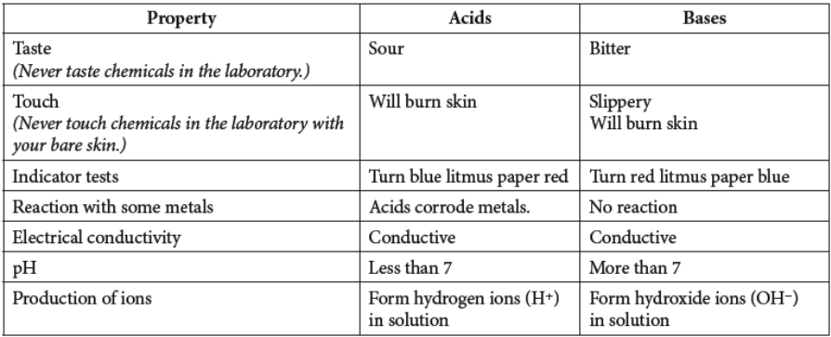

Quick Check
1. Identify each by their formula as acids, bases, or salt.
(a) HI ______________________
(b) KOH _____________________
(c) NaCl ____________________
(d) Ca(OH)₂ __________________
(e) MgBr₂ ___________________
(f ) H₃PO₄ ___________________
2. Which ion is in high concentration in an acidic solution? ______________________________
3. Which ion is in high concentration in a basic solution? ________________________________

Sample Questions Explained
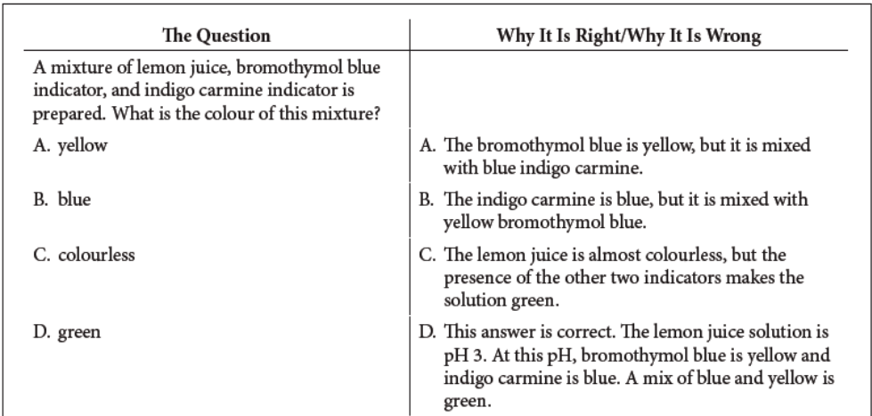
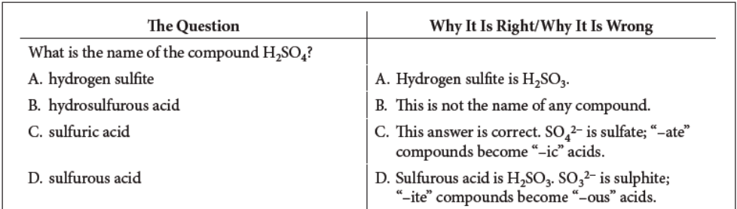
Practice Questions. Circle the correct answer.
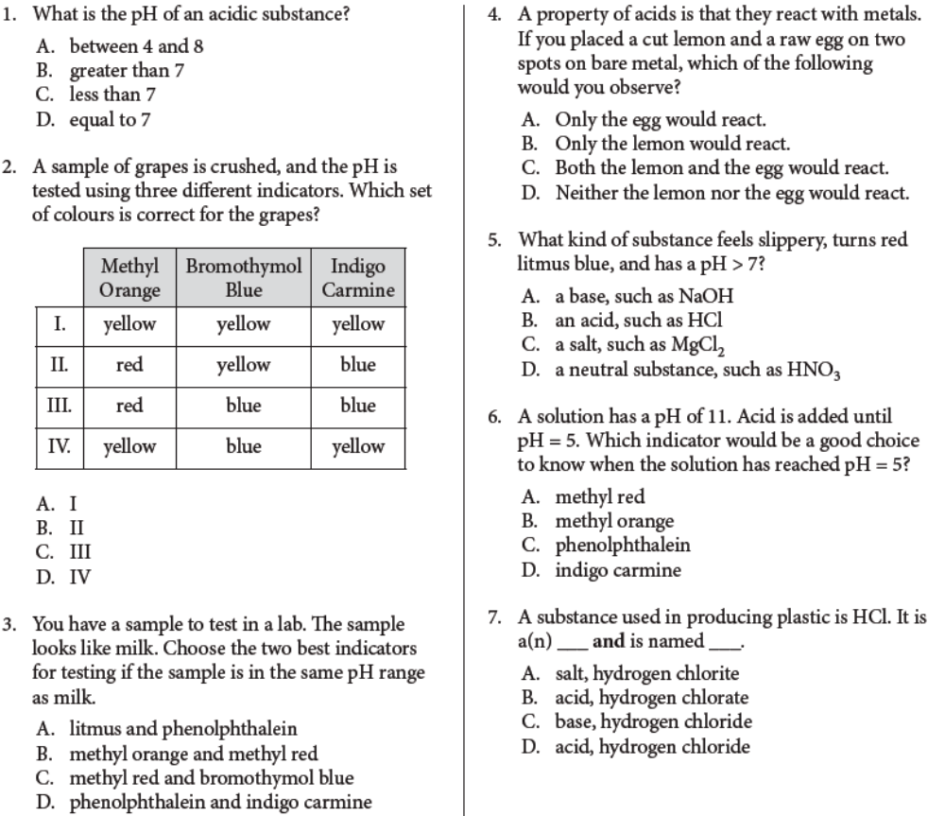
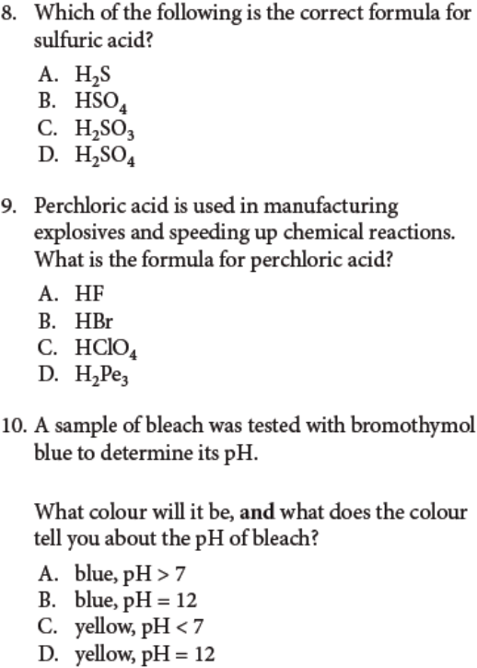
Acid-Base Neutralization and Metal Oxides and Non-Metal Oxides
1. Neutralization reactions occur when an acid and a base react to produce a salt and water.
Example: HCl(aq) + NaOH(aq) → NaCl(s) + H₂O(ℓ)
acid base salt water
2. A metal oxide is a chemical compound that contains a metal chemically combined with oxygen.
• Metal oxides react with water to form bases.
Example: Na₂O(s) + H₂O(ℓ) → 2NaOH(aq)
3. A non-metal oxide is a chemical compound that contains a non-metal chemically combined with oxygen.
• Non-metal oxides react with water to form acids.
Example: SO₂(g) + H₂O(ℓ) → H₂SO₃(aq)
• Non-metal oxides are formed from the burning of fossil fuels.
• Non-metal oxides dissolve in rainwater to produce acid precipitation.

Quick Check
1. Identify each of the following as an acid, a base, a salt, a metal oxide, or a non-metal oxide.
(a) Ba(OH)₂ ____________________________________
(b) H₂SO₄ _____________________________________
(c) NaCl ______________________________________
(d) K₂O _______________________________________
(e) SO₂ _______________________________________
2. Which kinds of oxides react with water to form acid precipitation? ______________________
3. Complete and balance the following neutralization reactions.
(a) ____ HF + ____ KOH → _______________________________________________
(b) ____ H₂SO₄ + ____ NaOH → ___________________________________________
(c) ____ HNO₃ + ____ Mg(OH)₂ → _________________________________________

Sample Exam Question Explained
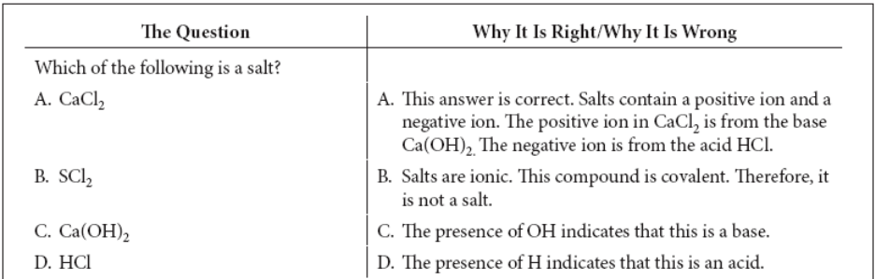
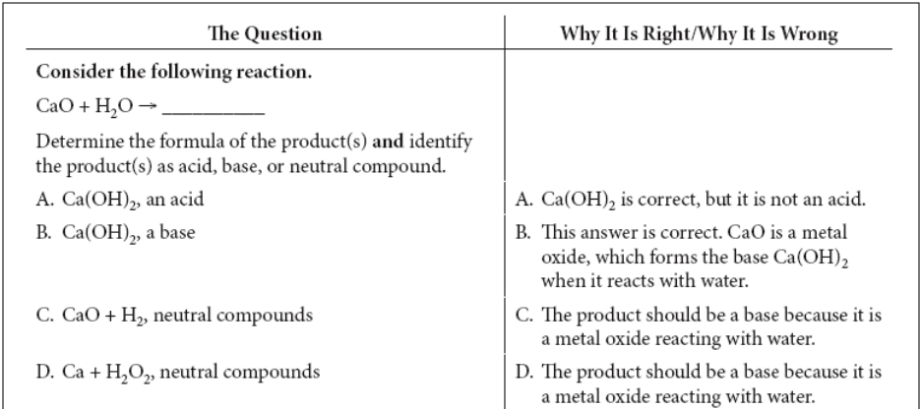

Practice Questions. Circle the best answer
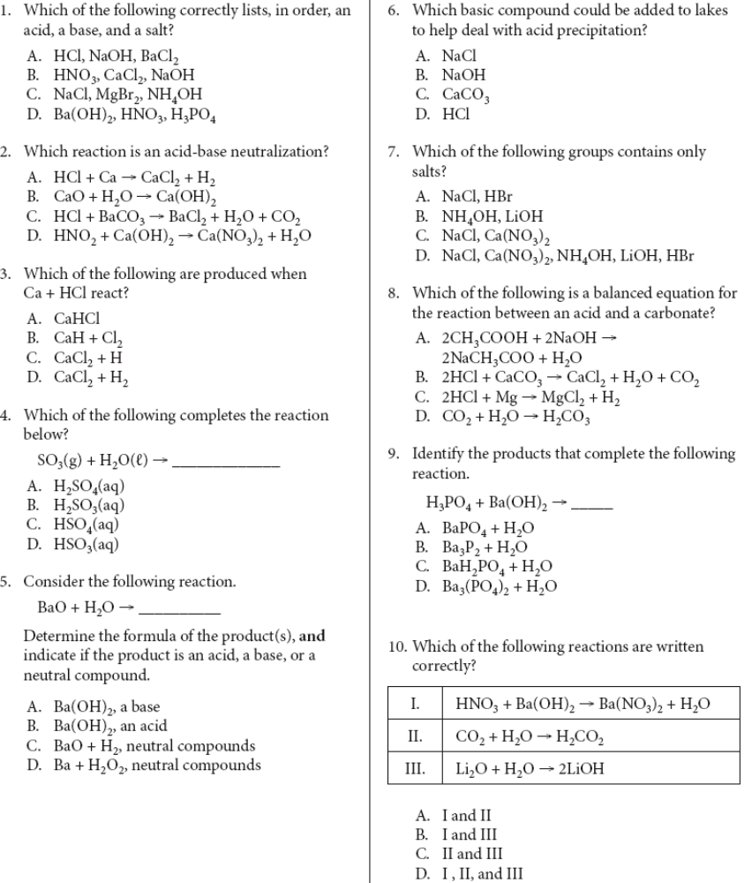
Types of Chemical Reactions
I. Summary of Key Points
• Chemical reactions can be classified as one of six main types: synthesis, decomposition, single replacement, double replacement, neutralization (acid-base), and combustion.
• You can identify each type of reaction by examining the reactants.
• This makes it possible to classify a reaction and then predict the identity of the products.

1. Synthesis (combination) is a type of chemical reaction in which two or more elements or compounds combine to form a single compound.
• A + B → AB where A and B represent elements
Example: 2Na + Cl₂ → 2NaCl
2. Decomposition is a type of chemical reaction in which a compound is broken down into two or more elements or simpler compounds.
• AB → A + B where A and B represent elements
Example: 2H₂O → 2H₂ + O₂
3. Single replacement is a type of chemical reaction in which one element replaces another element in a compound.
• A + BC → B + AC where A is a metal. Example: 2Al + 3CuCl₂ → 3Cu + 2AlCl₃
• A + BC → C + BA where A is a non-metal. Example: F₂ + 2NaI → I₂ + 2NaF
4. Double replacement is a type of chemical reaction in which elements in different compounds
exchange places.
• AB + CD → AD + CB
Example: K₂CrO₄ + 2AgNO₃ → Ag₂CrO₄ + 2KNO₃
5. Neutralization (acid-base) is a type of chemical reaction in which an acid and a base combine to produce a salt and water.
• Acid + base → salt + water
HX + MOH → MX + H₂O where X and M are elements
Examples: H₂SO₄ + Ca(OH)₂ → CaSO₄ + 2H₂O
6 Combustion is a type of chemical reaction in which oxygen is one of the reactants and where heat is produced.
• C_{X}H_{Y} + O₂ → CO₂ + H₂O where X and Y represent integers
Example: CH₄ + O₂ → CO₂ + 2H₂O

Quick Check
Classify each reaction as synthesis, decomposition, single replacement, double replacement, neutralization, or combustion.
(a) 2KBr → 2K + Br₂ ____________________________________________________________
(b) Cu + AgNO₃ → Cu(NO₃)₂ + Ag _________________________________________________
(c) 3Ca(NO₃)₂ + 2Na₃PO₄ → 6NaNO₃ + Ca₃(PO4)₂ ____________________________________
(d) 2C₆H₆ + 15O₂ → 12CO₂ + 6H₂O ________________________________________________
(e) 6Mg + P₄ → 2Mg₃P₂ _________________________________________________________
(f ) Ca(OH)₂ + H₂SO₄ + → 2H₂O + CaSO₄ ___________________________________________

Sample Question Explained
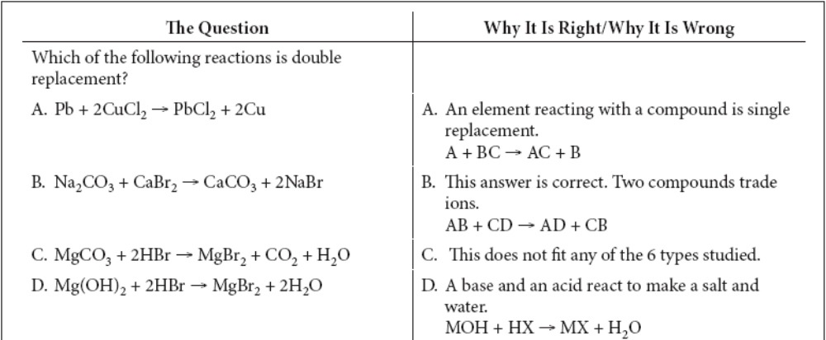
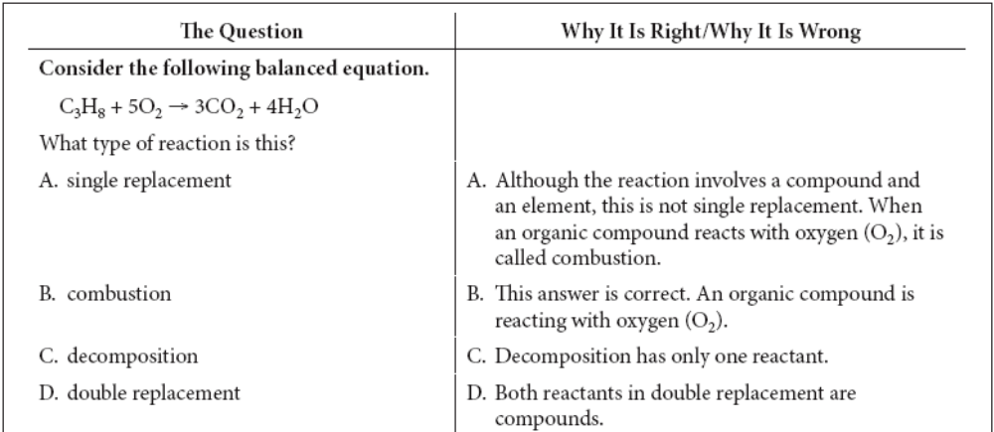

Practice Question. Circle the best answer.
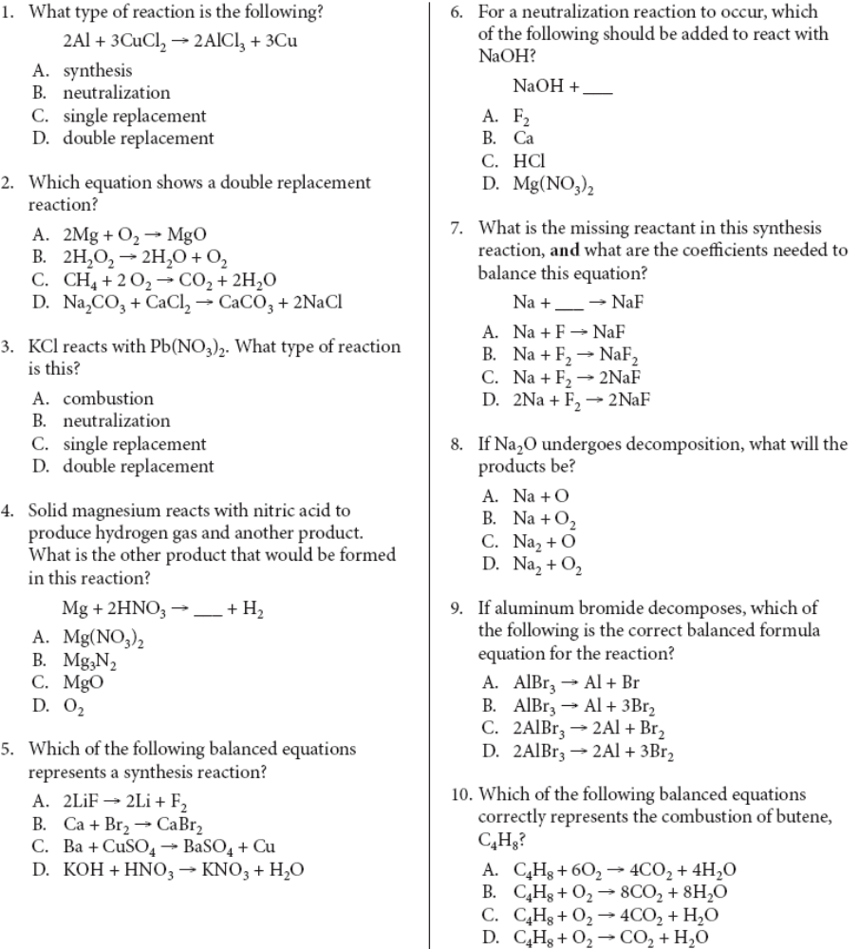
Factors Affecting the Rate of Chemical Reactions
I. Summary of Key Points
• Four main factors affect the rate of chemical reactions:
temperature (hotter is faster),
surface area (the more surface contact between reactants, the faster the reaction),
concentration (the greater the concentration, the faster the reaction rate),
presence of a catalyst (the catalyst helps the reaction go more quickly but is still present in the same amount at the end of the reaction).

Sample Question Explained
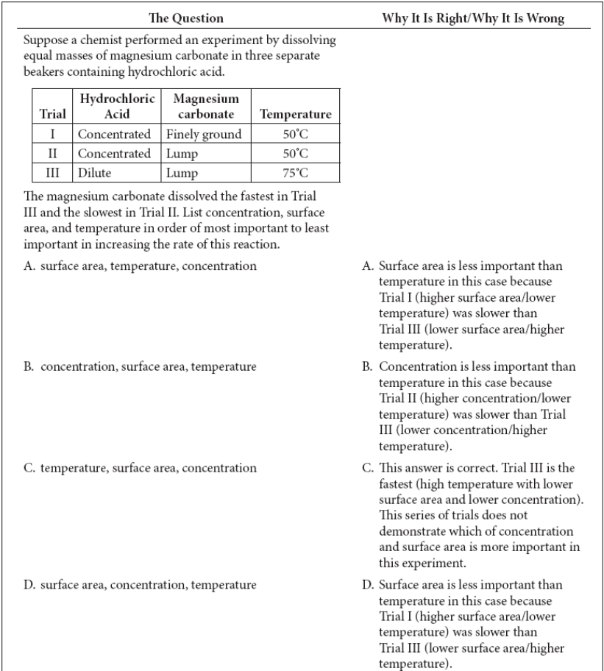
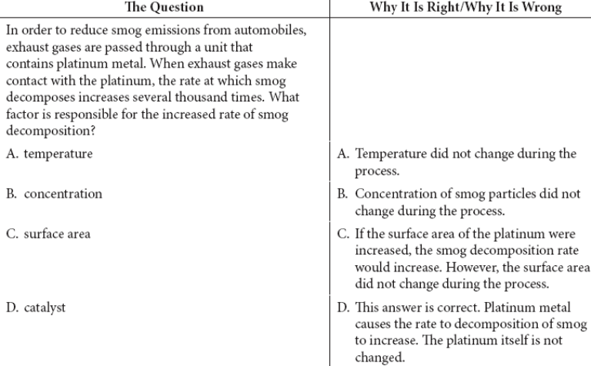
Practice Questions. Circle the best answer.
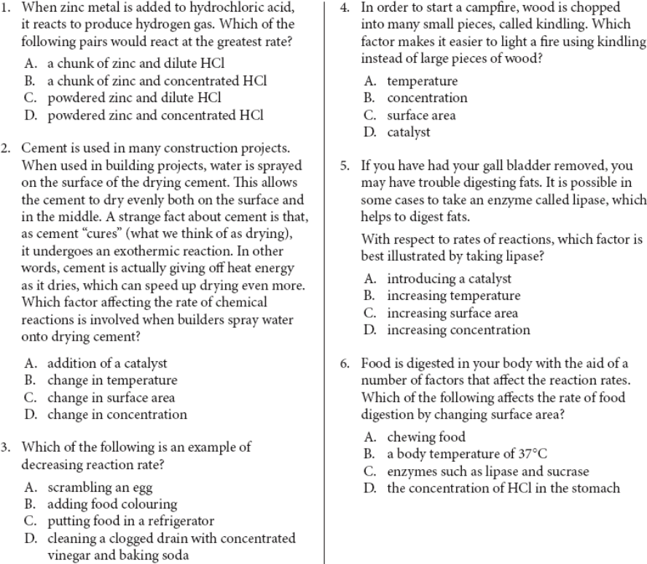
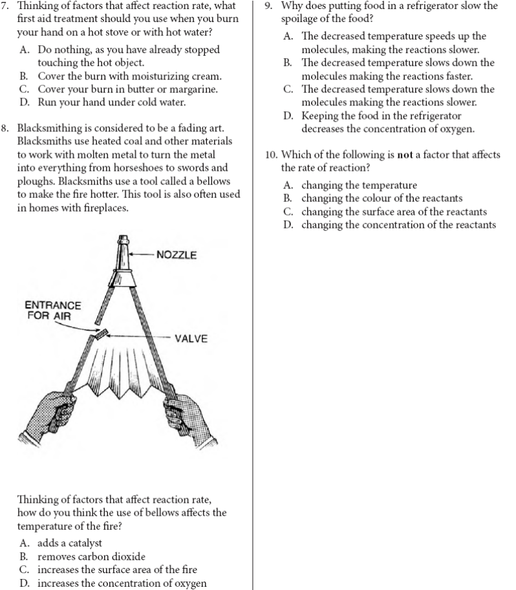
Organic Compounds
1. Organic compounds contain carbon and usually contain hydrogen.
• Organic molecules always have C before H in their formulas.
– This differentiates organic compounds from acids, which almost always start with H.
2. Inorganic compounds are compounds that do not have carbon.
• Some exceptions to this rule include carbon dioxide and carbon monoxide, which are inorganic compounds even though they contain carbon.
• Other exceptions to the rule are that carbonates (e.g., CaCO₃) and carbides (e.g., SiC) are inorganic.
3. Organic compounds can be represented in several different ways as shown in the table below.
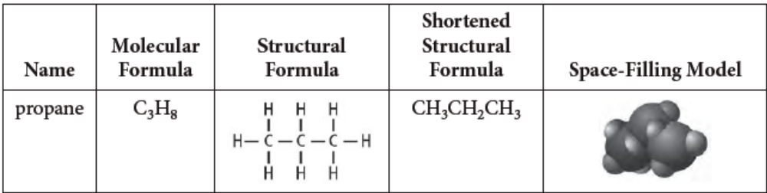

Hydrocarbons
1. A hydrocarbon is an organic compound that contains only carbon and hydrogen.
• Hydrocarbons are based on a carbon chain, with hydrogen atoms on the sides.
2. The simplest hydrocarbons are methane (CH₄), followed by ethane (C₂H₆), propane (C₃H₈),
butane (C₄H₁₀), and pentane (C₅H₁₂).
3. All hydrocarbons are flammable.

Sample Question Explained
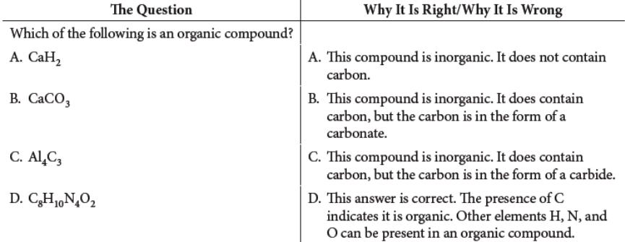
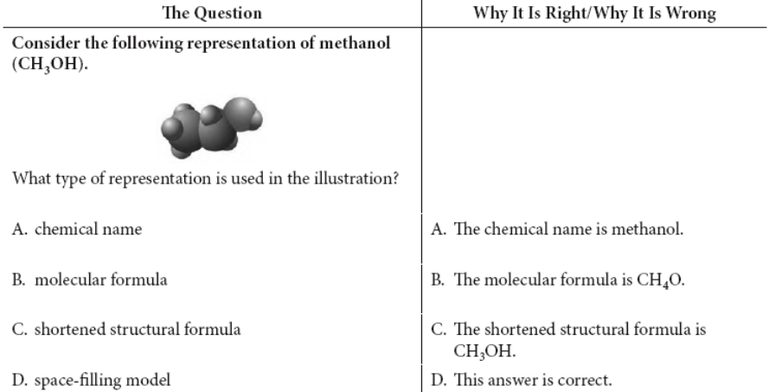
Practice Questions. Circle the best answer.


