Science 10 Name:
Number #
Acids and Bases
Slide 4 – Acids, Bases, and Neutral

- Acids are chemical compounds with a pH of
- Bases are chemical compounds with a pH of
- ph of 7 is

Slide 5 – Examples of Acids

- Stomach acid
- Citrus fruits
- Vinegar
- Car batteries
- Acid rain

Slide 6 – Examples of Bases

- Blood
- Baking Soda
- Drano
- Egg Whites
- Bleach
- Soap

Slide 7 – Properties of Acids and Bases

Acids | Bases
- pH less than 7  - Sour taste  - Corrosive  - Turns blue litmus red  - Contains hydrogen ions (H⁺)  - Usually has an H at the left side of the formula | - pH greater than 7  - Bitter taste  - Slippery, soapy and corrosive  - Turns red litmus blue  - Contains hydroxide ions (OH⁻)  - Usually has an OH at the right side of the formula

Slide 8 – Identifying Acids 101

- Acids have

- Example: HCl, H₂SO₄, NHO₃, etc.

Slide 9 – Identifying Bases 101

- Bases have

- Example: NaOH, Mg(OH)₂, Ca(OH)₂, etc.

Slide 10 – Warning!!!

- Some acids/bases are corrosive (can burn through things)
- You should NEVER test whether a solution is an acid or base by tasting or touching

Slide 12 – The Safe Way!

- pH indicators are chemicals that change
Examples:
  - Litmus paper
  - Methyl Orange
  - Bromothymol Blue
  - Phenophthalein
  - Indigo Carmine
  - Magnesium Ribbons

Slide 13 – pH Indicators

These indicators change color, depending on what they are put in:

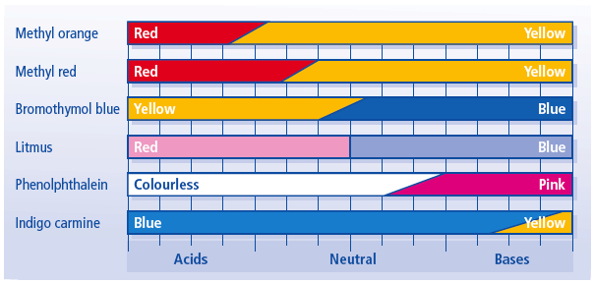

Slide 14 – Practice

- What colour is litmus paper in an acidic solution?
- What colour is bromothymol blue at a pH of 5? 7? 9?
- Is a solution an acid or a base if you add methyl orange and it turns yellow?
- Is a solution an acid or a base if you add phenolphthalein and it’s colourless?

Slide 15 – Lab Tomorrow!

- Read the pH indicators lab and be prepared to perform this lab tomorrow.

- DO NOT LOSE, FORGET, or DESTROY this lab. It is the only copy you will get and if you do lose, forget or destroy it, you will have to write it all out BY HAND!

