Science 10 Name:
Nuclear Reactions

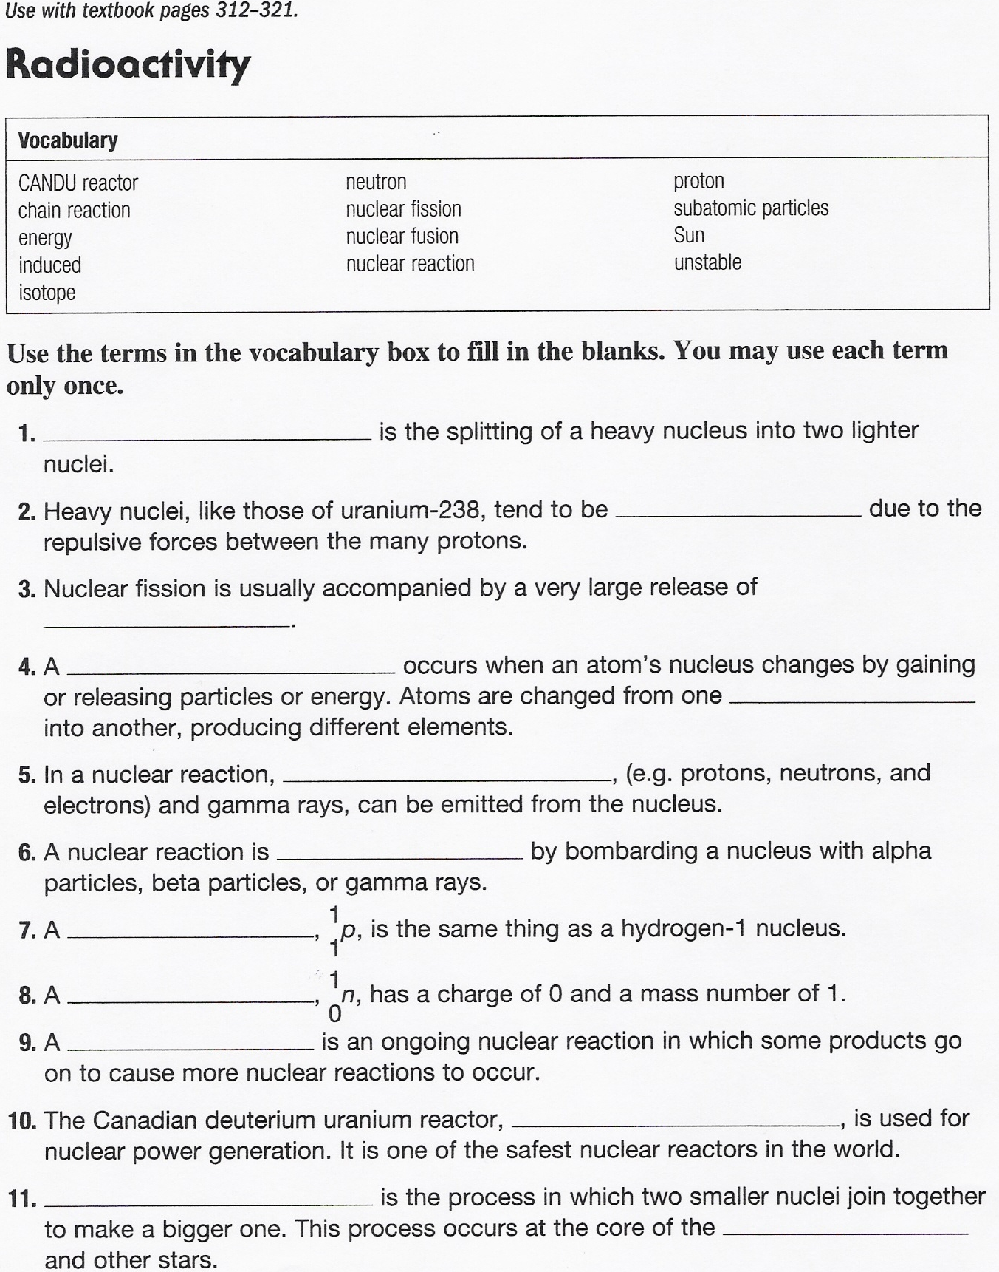

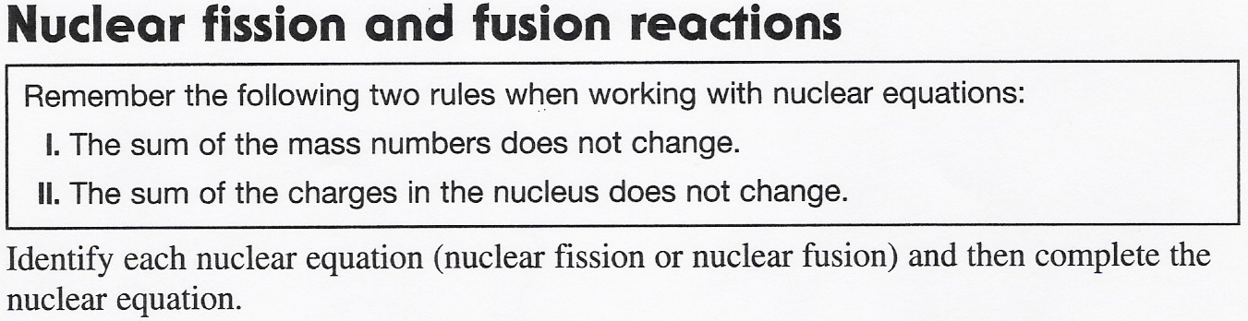
 | Balanced nuclear reaction | Nuclear fission or nuclear fusion
1 | 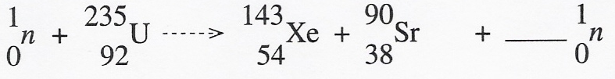
2 | 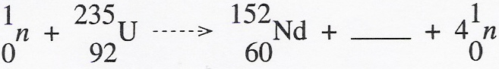
3 | 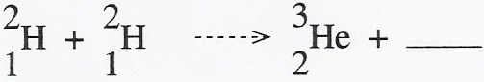
4 | 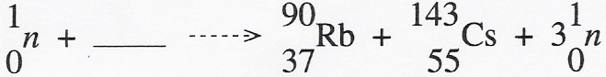
5 | 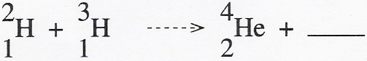
6 | 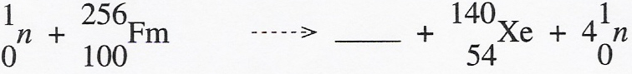
7 | 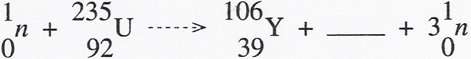
8 | 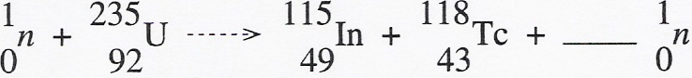
9 | 

