Name:
Bohr Diagrams Date:
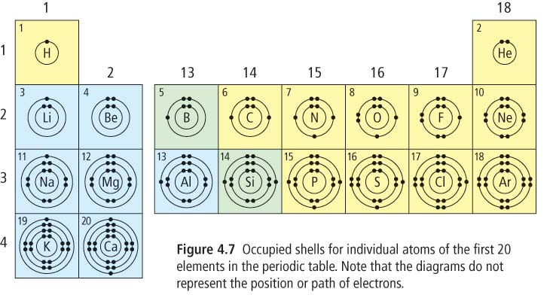

Bohr Diagram = a diagram that shows how many ______________________ are in each ___________________

_________________________

The first shell can hold up to _________ electrons maximum

Each shell after can hold up to _________ electrons maximum

The outermost shell that contains electrons is called the ______________________________________________

_____________________________________ are the electrons that are in the outermost shell

*** These electrons are the ones involved in ____________________________________________________________

The element’s ________________________________________ tells you how many energy shells are involved with it
So, elements in period ________ fill the 1st valence shell

Elements in period 4 fill the ______________ valence shell, etc.

(EXCEPT for the transition metals), the element’s _____________________________________ tells you how many electrons are in the outermost shell

So, elements in group _______ have 2 valence electrons

Elements in group 7 have _________ valence electrons

Noble gases have a _____________ valence shell (hence why they are so stable and non-reactive)

Ok, now practice!
Name:
Lewis Diagrams Date:
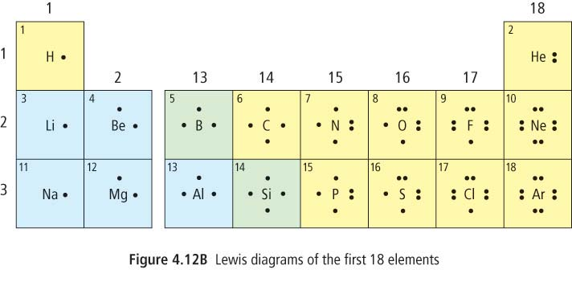
Lewis Diagrams shows only the element’s ____________________________________________
These are important because they are the ones involved in ___________________________________________

The electrons are represented as dots _________________________ until the 5th electron, and then they are _______________________________________

Notice:
Elements in the _________________________________ have only __________ electron
Elements in the _________________________________ have only __________ electrons
Elements in the _________________________________ have __________ electrons

Electrons ______________________ one at a time from _________________________________ across each period

Think about it: look at how many valence electrons are in the valence shells of the alkali metals versus the noble gases. Do you think this contributes to the element’s reactivity in those groups? Explain why or why not? (With what you know right now… don’t look it up!)

