Science 10 Mr. Harwood
Number #
Intro to the Atomic Theory
Slide 2 - Matter

- What is matter?

- What is matter made up of?

Slide 3 – Atoms

- What are atoms made up of?

- What are subatomic particles?

Slide 4 – Subatomic Particles

- What are the 3 types of subatomic particles?

Slide 5 - Protons

- Represented as:
- Have a +1 electrical charge
  - Positive Protons
- Have a relative mass of ~
- Located in the atom’s

Slide 6 – Neutrons

- Represented as:
- Has no electrical charge
  - No charge neutrons
- Have a relative mass of ~
- Located in the atom’s

Slide 7 - Electrons

- Represented as:
- Have a -1 electrical charge
  - Negative electrons
- Have a relative mass of ~
- Located in the atom’s

Slide 8 – Comparing the 3 Subatomic Particles

 | Symbol | Electrical Charge | Relative Mass | Location in the Atom | What it accounts for
Protons

Neutrons

Electrons

Slide 9 – Anatomy of an Atom

- Nucleus =

- Electrons =

Slide 10 – Atomic Number and Mass
- Atomic Number

- Atomic Mass

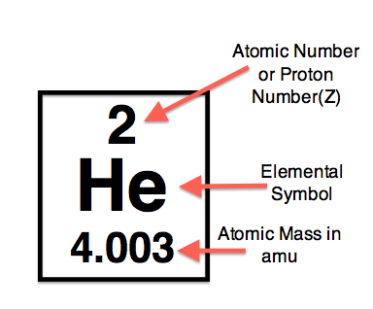

Slide 11 – Neutral Atoms
- There are the same number of p+ in an atom as e-

- Together, these two charges cancel each other out, making the atom neutrally charged
- Example: Potassium (K) has an atomic number of 19. That means there are 19 protons in the nucleus. That means there are also 19 electrons in the atom.

Slide 12 – Practice
- For Boron:
  - What is the atomic number?
  - What is the atomic mass?
  - How many protons are in the atom?
  - How many neutrons are in the atom?
  - How many electrons are in the atom?

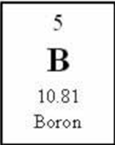

Slide 13 – Practice
- For Silicon:
  - What is the atomic number?
  - What is the atomic mass?
  - How many protons are in the atom?
  - How many neutrons are in the atom?
  - How many electrons are in the atom?
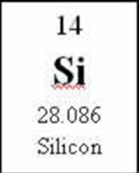
Slide 13 – Nuclear Charge
- Nuclear Charge =
- Since the protons are the only subatomic particle in the nucleus with a charge, the nuclear charge = the number of protons
- Atomic # =
- The atomic number for Carbon is 6. That means there are 6 protons in the nucleus. That also mean that the nuclear charge is +6.
  - What are the nuclear charges on the rest of these elements?

Slide 14 – Review
- What are the charges on the subatomic particles?
- What particle(s) account for the atom’s mass?
- What particle(s) account for the atom’s volume?
- What is a neutral atom?
Homework
  - Read pg. 170-171
  - Complete the Atomic Structure WS

Atomic Structure Worksheet

Fill in the blanks for the elements in this chart.

Element | Element Symbol | Number of Protons | Number of Neutrons | Number of Electrons | Atomic Mass | Atomic Number | Nuclear Charge
lithium

 |  | 6
 |  |  |  | 17
 | Ag
 |  |  |  |  |  |  | 82
 |  |  |  |  | 40.1
tantalum

 |  |  |  |  |  | 88

