Science 10 Name:
Climatographs
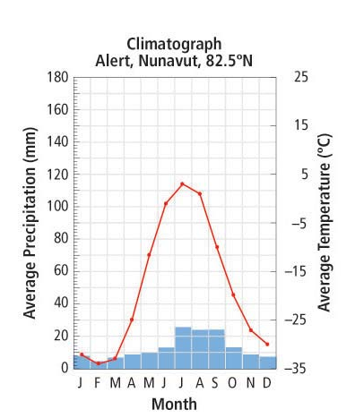
What month has the highest average precipitation?
What month has the lowest average precipitation?
What month has the highest average temperature?
What month has the lowest average temperature?
In October what is the average precipitation and average temperature?
What month has an average precipitation of 10 mm?
What months have an average temperature less than zero degrees?

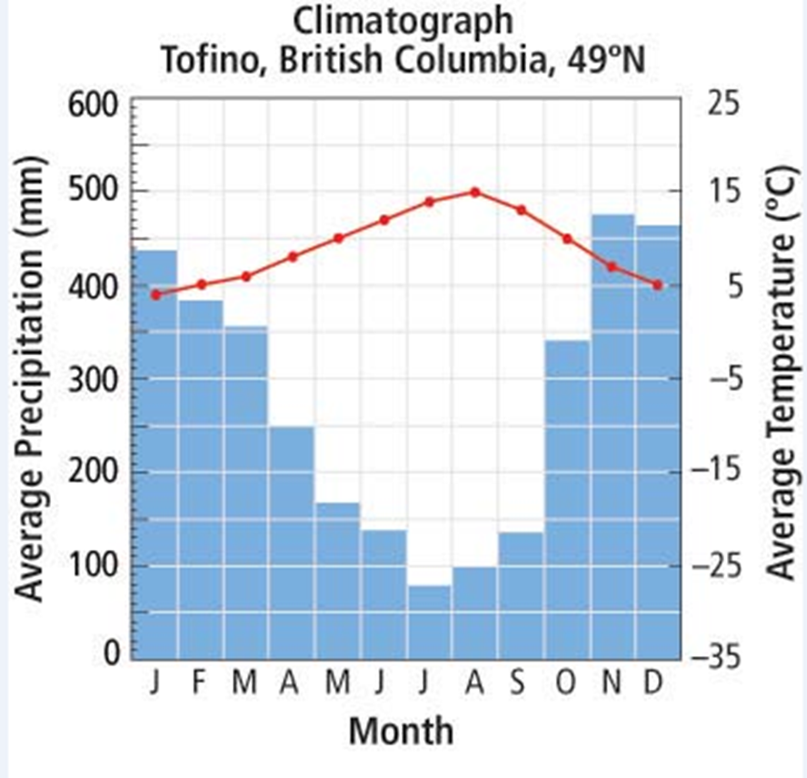
What month has the highest average precipitation?
What month has the lowest average precipitation?
What month has the highest average temperature?
What month has the lowest average temperature?
In July what is the average precipitation and average temperature?
What month has an average precipitation below 300 mm?
What months have an average temperature greater than 10 degrees?

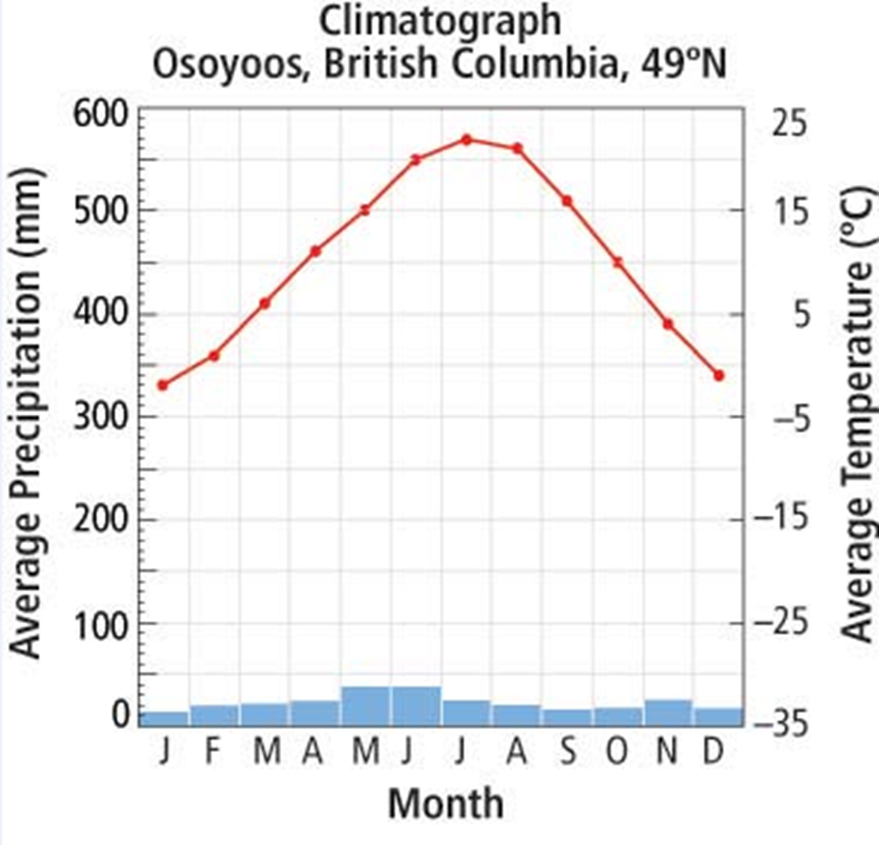
What month has the highest average precipitation?
What month has the lowest average precipitation?
What month has the highest average temperature?
What month has the lowest average temperature?
In March what is the average precipitation and average temperature?
What months have an average precipitation below 50 mm?
What months have an average temperature less than zero degrees?

